Progress Report - Iteration 1

This progress report serves as a comprehensive overview of our group's activities and reflections during Iteration 1 for Team JZTC..

Group members:

**Joenella Hiko**

**Zoe Proudfoot**

**Tainui Weti**

**Cairo Bullen**

# Group Reflection

**Key learnings:**

* Clear and open communication within the team is vital to getting the work done.

**Challenges faced:**

* The first meeting was challenging, the group was unfamiliar with one another and the assessment requirements. However, in the meetings to follow, communication improved, and some progress was made.
* Team members who were not available or present made collaboration difficult.

**Achievements:**

* As a team, we all contributed towards completing agile tasks for iteration 1 of the assessment.

**Plans on improvement for Iteration 2:**

* Everyone must have a clear understanding of the assessment and our objectives.
* We must work towards becoming better team players by communicating, cooperating, and participating equally. Work together, share ideas and help each other out.
* Make sure to edit work before submitting. Each team member is responsible for spelling and punctuation check.

Individual Contributions

## Joenella

As the Project Manager, I was responsible for the team meetings, work being delegated, requirements being met and meeting deadlines. I can support this by being present at every meeting, communicating face-to-face, email and chat.

Project Manager tasks included:

Filling out own section of the stakeholder register

Creating a persona (Tracey Jones).

I contributed to the testing of the two other personas also. (See Reply on Persona discussion on myEIT).

Creating the Progress Report so that each member can contribute towards the group reflection and their own contributions.



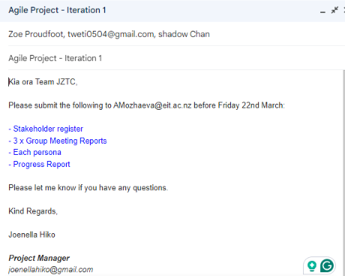

## Zoe

## Tainui

Tainui to enter

## Cairo

Created a persona ( Mary Jane)

|  |  |
| --- | --- |
|  |  |